Application Store

Problem Definition:-

In this fast paced world of smartphones, more than five thousand applications are getting released everyday on multiple platforms like Android, iOS, WindowsPhone etc. The oobjective of our project is to create a cross platoform mobile application store which can give a lot of variety and flexibility in one place. This is one of its kind store which supports maximum devices compared to any other application store and thus has a wider market.

We have created a database which can store applications supporting all the mobile platforms. It can incorporate all the versions of a particular applliction. It also tracks details of each and every company dealing with our application store and gives them space for advertising their apps.

The exciting feature of this store is that it includes various products including Music, Movies, Ebooks along with traditional applications and games.

We have given prime focus on Business Inteligence and analysis and created BI reports which can help operations of various sectors of the company.

Use case Diagram:-

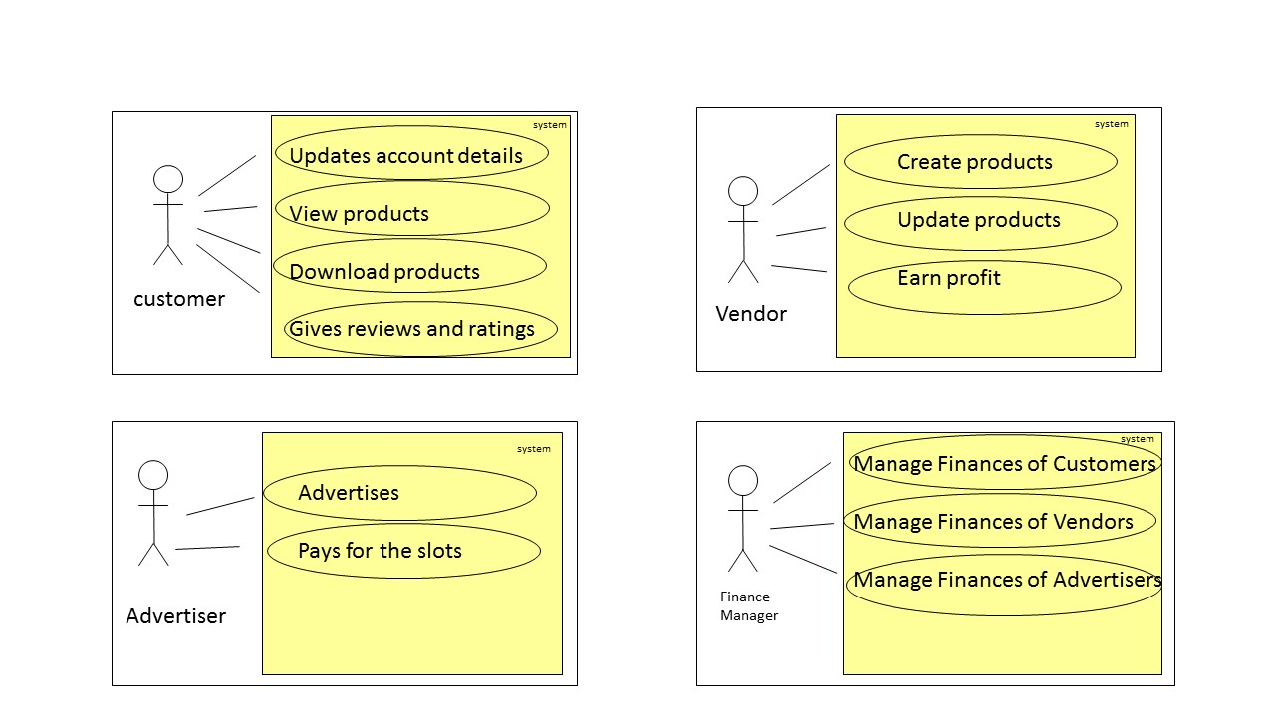

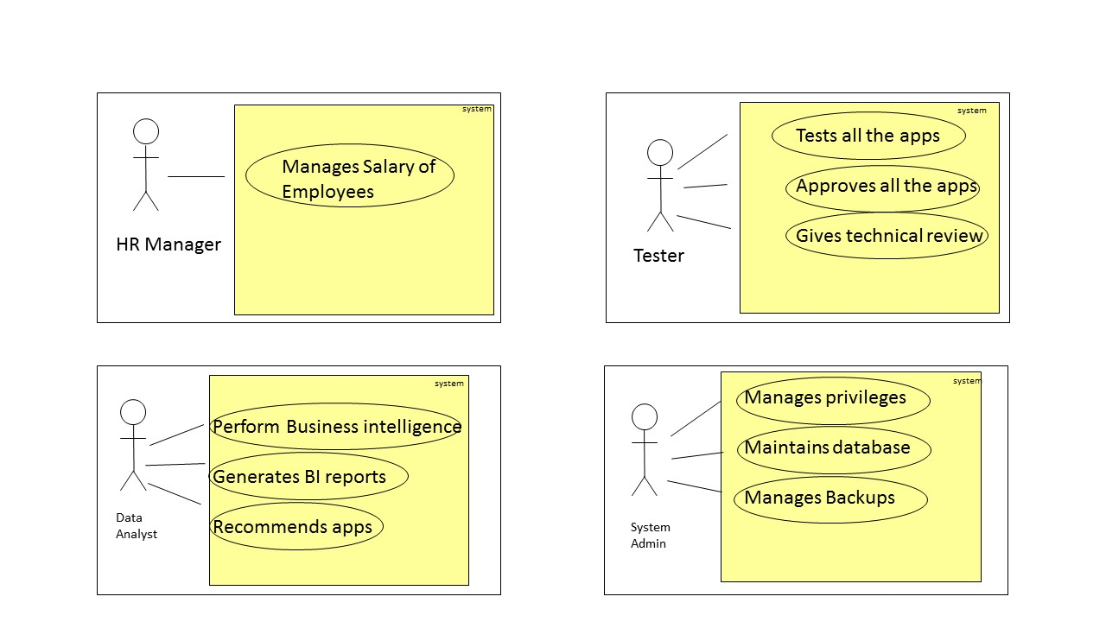

EER diagram is as follows:-

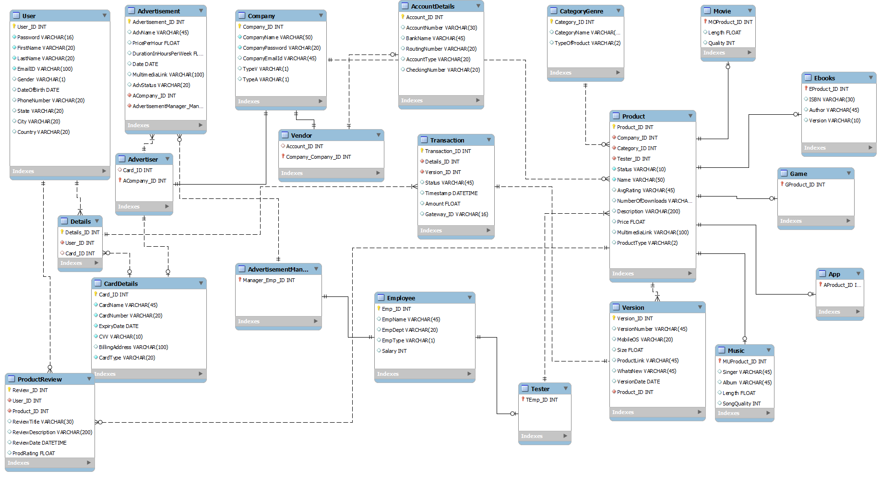

Normalization :- The mian purpose of normalization is to remove data redundancy and anamolies created while performing INSERT,UPDATE and DELETE operations.

We have normalized all the tables to 3NF.

Eg:- In product table, we have normalized the attribute Category by making another table called as ‘CategoryGenre’ and referencing it in the main Product table. This reduces data redundancy.

**Product**

|  |  |  |  |  |
| --- | --- | --- | --- | --- |
| Product_ID | Name | VersionID | ………….. | CategoryID(FK) |

**CategoryGenre**

|  |  |  |  |
| --- | --- | --- | --- |
| CategoryID(PK) |  | CategoryName | TypeofProduct |

Similarly, all other tables have been normalized and data redundancy has been reduced.

Views:-

1. CustomerView( User_view):-

This is the view which can be seen by customers. It includes all the information of all the apps including multiple ProductReviews and Ratings.

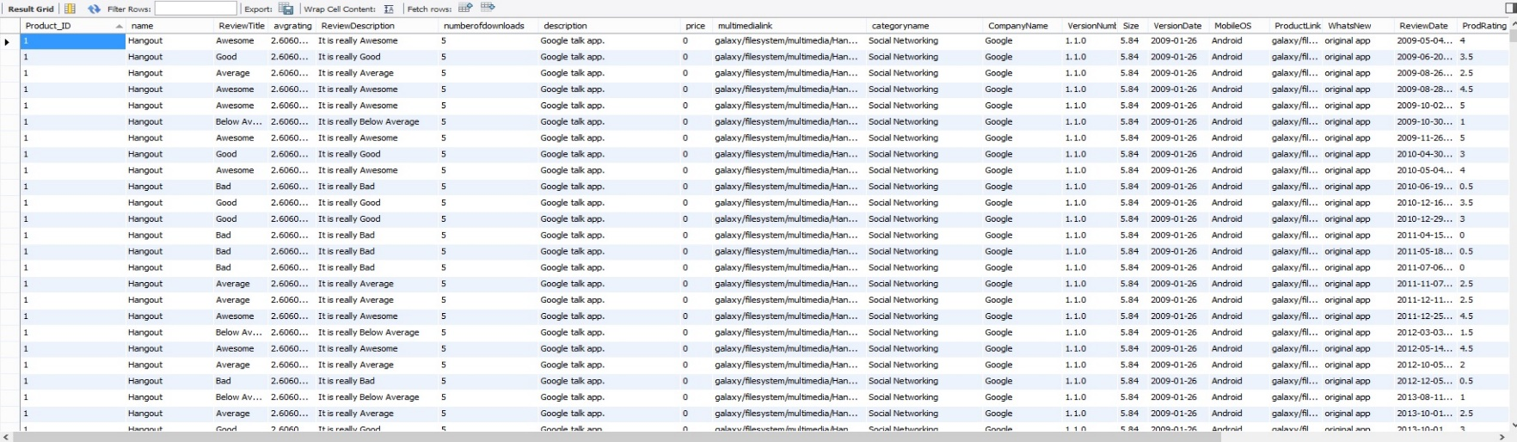

1. Non-HR( Non_HR):-

This is the view which consists of all the attributes of Employee table except for the salary column. This view can be seen by all the employees except for HR and Finance employees(which have access to all the attributes).

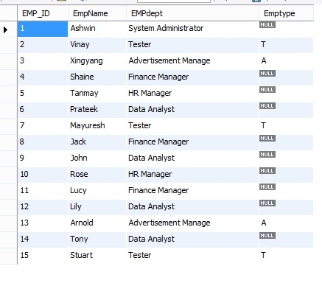

1. Customer_Product(user_product) :-

This view contains information about every entity in the transaction table namely customer, product, Company and its various versions. This view is aimed at making Business Intelligence reports. Data Analyst will be given privilege to this view.

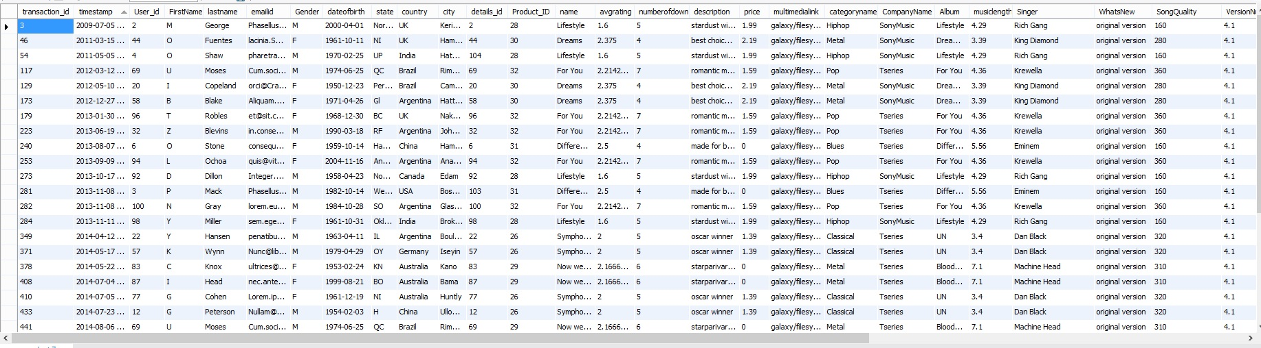

1. Application(application_view) :- This view shows us the information about all applications.

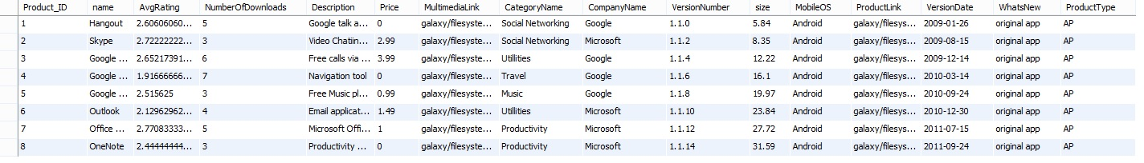

1. Games( game_view) :- This view shows us the information about all games.

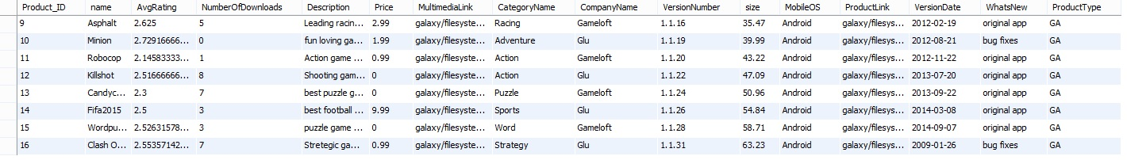

1. Music ( music_view) :- This view shows us the information about all songs.

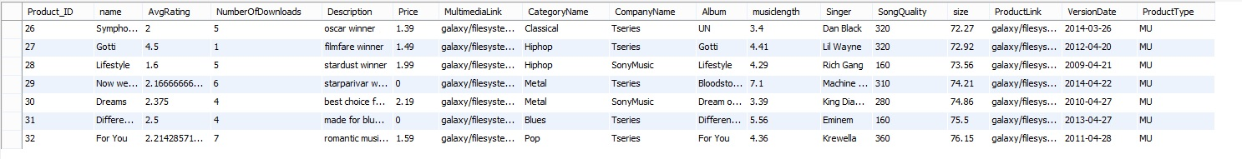

1. Movie( movie_view) :- This view shows us the information about all movies.

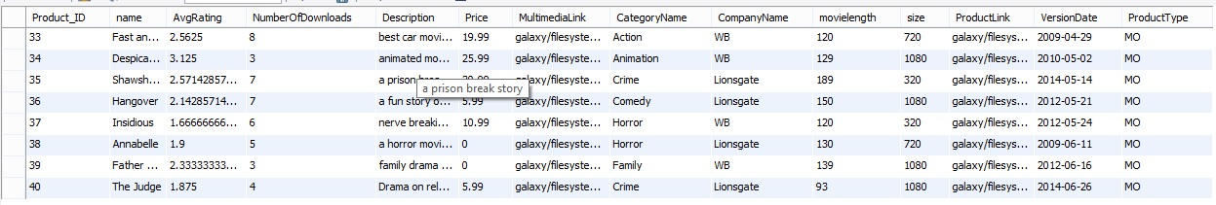

1. Ebooks( ebook_view) :- This view shows us the information about all ebooks.

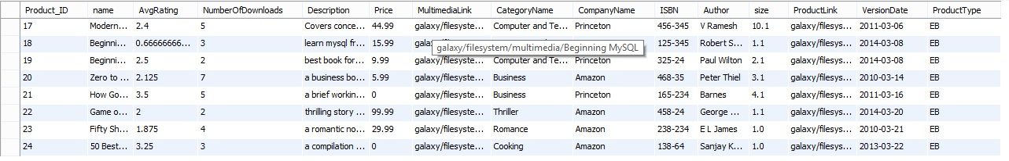

Procedures:-

Procedures improves the performance of the database significantly. Its basically set of queries which are pre compiled which need to be executed frequently.

1. Product details ( sp_productdetails) :-

This is a parametric procedure which takes two parameters – ProductID and MobileOS , and displays the entire information corresponding to those parameters. It automatically checks the releasedate and displays the information of the latest version of the product.Every product type has its unique categories and need diiferent tables to be joined with product table. Thus this procedure checks the product type of the productID given and displays the appropriate attributes. Eg for movies, it gives attributes – Length, quality

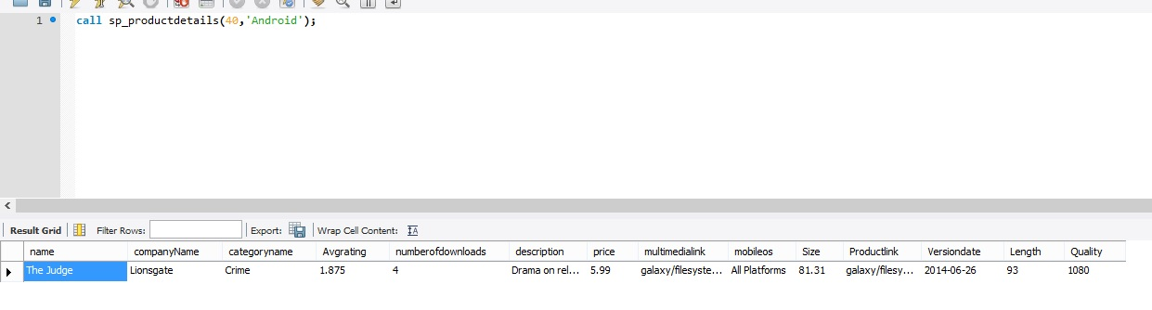

For music, it displays attributes – Length, SongQuality, Album, Singer

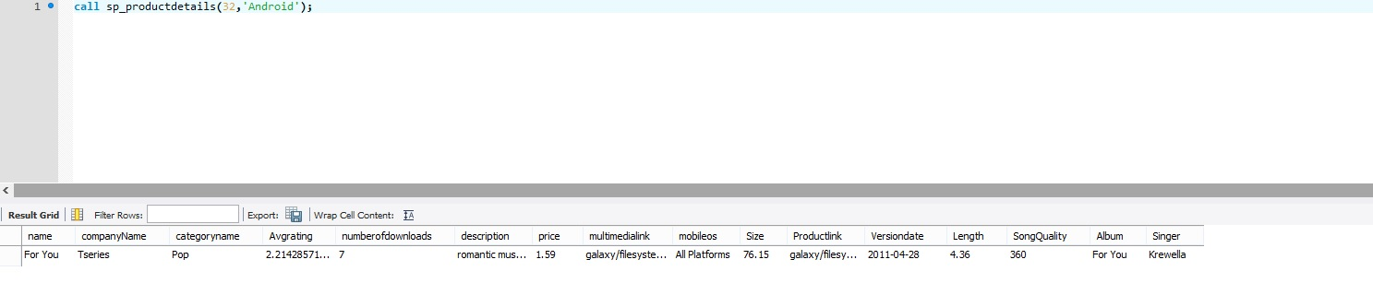

For applications, it displays – whatsnew.

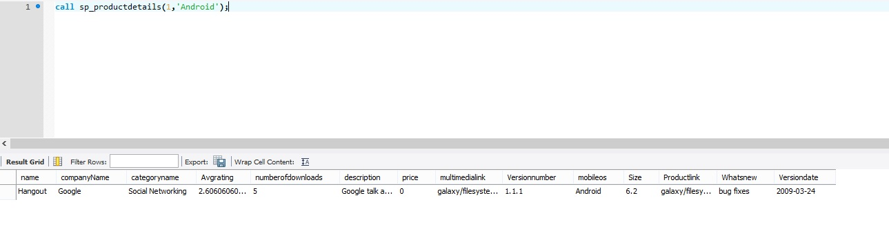

Following procedures are created for Business Intelligence and Analysis. According to Wikipedia – “Business intelligence (BI) is the set of techniques and tools for the transformation of raw data into meaningful and useful information for business analysis purposes.” [Source - Wikipedia]

1. Top Ten countries according to number of downloads (sp_top_ten_countries_downloads).

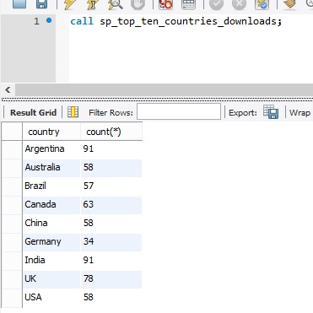

1. Best apps in each country (sp_best_apps_in_each_country)

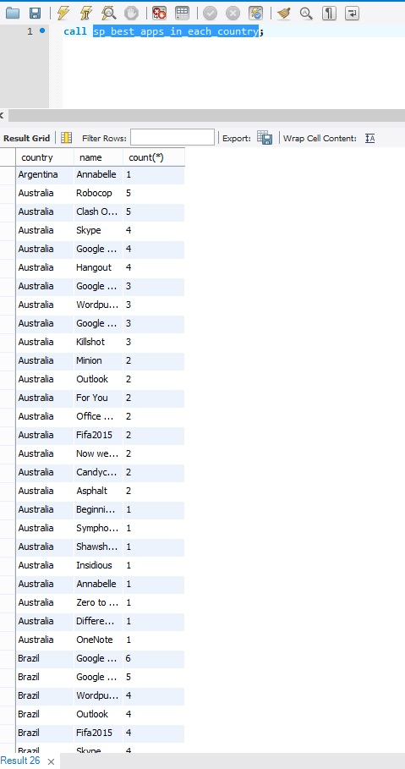

1. Countrywise OS analysis

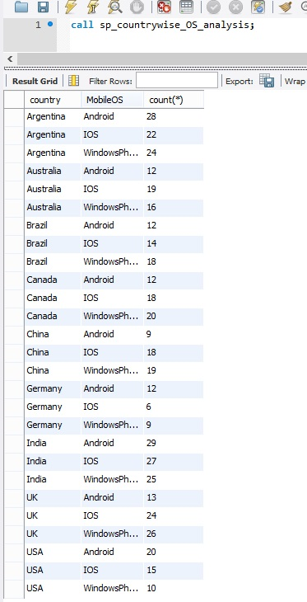

1. Top 10 apps in last one year, month, week

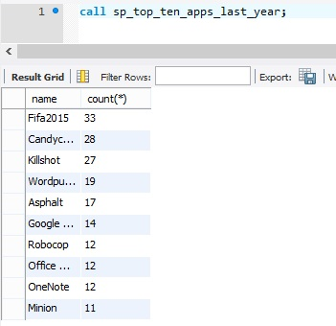

1. Top 10 free Apps + Games

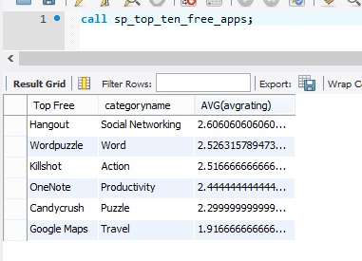

1. Top 10 paid apps + games

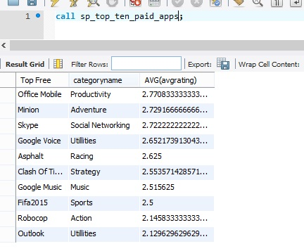

1. Top 10 most downloaded apps + games

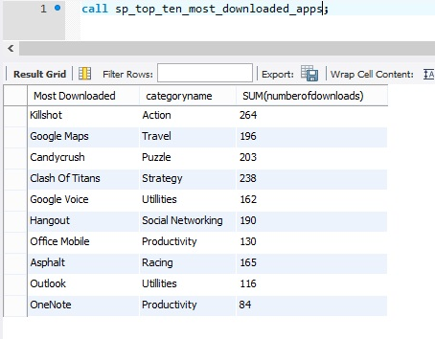

1. Top 10 companies with highest number of downloads

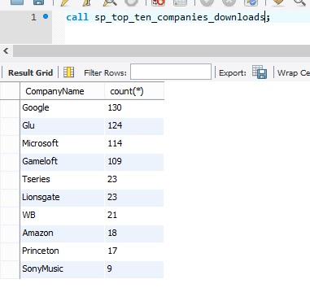

1. Top 10 companies with highest amount of sales

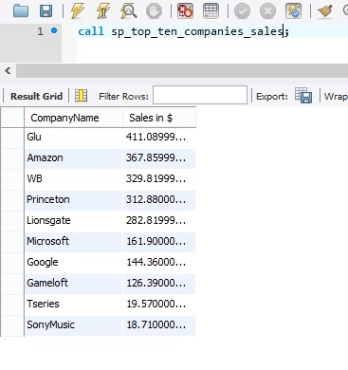

Privileges:- There are various kinds of users who can access different tables and/or attributes. Eg. Any employee except HR and Finance cannot view everyone’s salary. Thus different users are given different privileges on tables, views and databases.

1. Customer

Eg. Username- shaw

Password - shaw

**Tables**

User – Select, Update

Carddetails - Select, Update

Details - Select, Update

ProductReview - Select, Update

**Views**

User_view -Select

1. Vendor

Eg . username – Microsoft

Password – Microsoft

**Tables**

Company - Select, Update

AccountDetails - Select, Update

Vendor - Select, Update

Product - Select, Update, Insert

Version - Select, Update, Insert

App - Select, Update, Insert

1. Advertiser

Eg . username – apple

Password - apple

**Tables**

Company - Select, Update

Advertiser - Select, Update

Advertisement - Select, Update

CardDetails - Select, Update

1. Vendor+Advertiser

Eg – username – google

Password – google

**Tables**

Company - Select, Update

AccountDetails - Select, Update

Vendor - Select, Update

Product - Select, Update, Insert

Version - Select, Update, Insert

App - Select, Update, Insert

Advertiser - Select, Update

Advertisement - Select, Update

CardDetails - Select, Update

1. Ad Manager

Eg. Username – xingyang

Password – xingyang

**Tables**

Advertisement - Select, Update

**Views**

Non_HR - Select, Update

1. Tester

Eg. Username – vinay

Password – vinay

**Tables**

Product - All

Categorygenre- All

Version - All

App - All

Music - All

Game - All

Movie - All

Ebooks - All

**Views**

Non_HR – Select,Update

1. HR manager

Eg. Username – Tanmay

Password – Tanmay

**Tables**

Employee - All

1. Finance Manager

Eg . username – shaine

Password – shaine

Tables

Transaction - All

Carddetails - all

Accountdetails - all

Employee-select

1. Data Analyst

Eg . username – ashwin

Password – ashwin

**Databases**

Mydb – all

**Views**

User_product - all

1. System Admin

Eg . username –admin

Password –admin

**Databases**

Mydb – all

Triggers